To create a command to run a query automatically
Wrkjobscde, F6 to add new entry. Either:
For a command CALL PGM(CMS.CUS/CHKBYR), or
For a query RUNQRY QRY(PUR.QRY/QS04)
NOTE: for wrkscdjobe, CL can’t have RCDSLT(*YES)
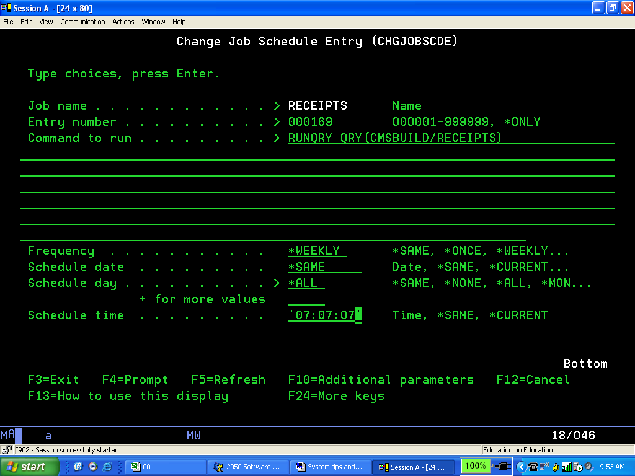
Either one of Schedule day or date must be *NONE.
As above, will run all 7 days weekly. To run one day weekly, put e.g. *FRI.
To run 2-6 days a week, change Schedule day to e.g. *MON, put + on the next line and Enter to go to supplemental screen and enter *TUE, *WED as required.

F10 Additional parameters, then PgDn. Not sure why but…change Recovery action to *NOSBM, Job queue to *JOBD, change User and Message queue as required, and add some useful text.
